​
UNITED STATES
SECURITIES AND EXCHANGE COMMISSION
Washington, D.C. 20549
​
FORM 8-K
CURRENT REPORT
Pursuant to Section 13 or 15(d)
of the Securities Exchange Act of 1934
​
Date of report (Date of earliest event reported): August 4, 2026
​
HARMONY BIOSCIENCES HOLDINGS, INC.
(Exact name of registrant as specified in its charter)
​

​ | ​ | ​
Delaware | 001-39450 | 82-2279923
(State or other jurisdiction | (Commission | (IRS Employer
of incorporation) | File Number) | Identification No.)
​
630 W. Germantown Pike, Suite 215
Plymouth Meeting, PA 19462
(Address of principal executive offices) (Zip Code)
(484) 539-9800
(Registrant’s telephone number, including area code)
N/A
(Former name or former address, if changed since last report.)
​
Check the appropriate box below if the Form 8-K filing is intended to simultaneously satisfy the filing obligation of the registrant under any of the following provisions:
☐ | Written communications pursuant to Rule 425 under the Securities Act (17 CFR 230.425)
​
☐ | Soliciting material pursuant to Rule 14a-12 under the Exchange Act (17 CFR 240.14a-12)
​
☐ | Pre-commencement communications pursuant to Rule 14d-2(b) under the Exchange Act (17 CFR 240.14d-2(b))
​
☐ | Pre-commencement communications pursuant to Rule 13e-4(c) under the Exchange Act (17 CFR 240.13e-4(c))
​
Securities registered pursuant to Section 12(b) of the Act:

​ | ​ | ​ | ​ | ​
​ | ​ ​ ​ | Trading | ​ ​ ​ | Name of each exchange
Title of each class | ​ | Symbol(s) | ​ | on which registered
Common Stock, $0.00001 par value per share | ​ | HRMY | ​ | The Nasdaq Global Market
​
Indicate by check mark whether the registrant is an emerging growth company as defined in Rule 405 of the Securities Act of 1933 (§230.405 of this chapter) or Rule 12b-2 of the Securities Exchange Act of 1934 (§240.12b-2 of this chapter).
​
Emerging growth company ☐
​
If an emerging growth company, indicate by check mark if the registrant has elected not to use the extended transition period for complying with any new or revised financial accounting standards provided pursuant to Section 13(a) of the Exchange Act. ☐
​
​
​
​
Item 2.02. Results of Operations and Financial Condition.
On August 4, 2026, Harmony Biosciences Holdings, Inc. (the “Company”) issued a press release announcing its financial results for the quarter ended June 30, 2026. A copy of this press release is attached as Exhibit 99.1 to this Current Report on Form 8-K and is incorporated herein by reference.
​
Item 7.01. Regulation FD Disclosure.
​
On August 4, 2026, the Company posted an investor presentation to its website at ttps://ir.harmonybiosciences.com (the “Investor Presentation”). A copy of the Investor Presentation is attached as Exhibit 99.2 to this Current Report on Form 8-K and is incorporated herein by reference. The Company expects to use the Investor Presentation, in whole or in part, and possibly with modifications, in connection with presentations to investors, analysts and others.
​
The information contained in the Investor Presentation is summary information that is intended to be considered in the context of the Company’s Securities and Exchange Commission (“SEC”) filings and other public announcements that the Company may make, by press release or otherwise, from time to time. The Investor Presentation speaks only as of the date of this Current Report on Form 8-K. The Company undertakes no duty or obligation to publicly update or revise the information contained in the Investor Presentation, although it may do so from time to time. Any such updating may be made through the filing of other reports or documents with the SEC, through press releases or through other public disclosure. In addition, the exhibit furnished herewith contains statements intended as “forward-looking statements” that are subject to the cautionary statements about forward-looking statements set forth in such exhibit. By furnishing the information contained in the Investor Presentation, the Company makes no admission as to the materiality of any information in the Investor Presentation that is required to be disclosed solely by reason of Regulation FD.
​
This Current Report on Form 8-K and its contents (including Exhibits 99.1 and 99.2) are furnished and shall not be deemed “filed” for purposes of Section 18 of the Securities Exchange Act of 1934, as amended (the “Exchange Act”), or otherwise subject to the liabilities of that section or Sections 11 and 12(a)(2) of the Securities Act of 1933, as amended (the “Securities Act”), nor shall it be deemed incorporated by reference in any filing under the Securities Act or the Exchange Act, regardless of any general incorporation language in such filing, except as shall be expressly set forth by specific reference in such filing.
Note Regarding Forward-Looking Statements
Certain statements in this Current Report on Form 8-K constitute “forward-looking statements” within the meaning of the federal securities laws. These statements are based on management’s current opinions, expectations, beliefs, plans, objectives, assumptions or projections regarding future events or future results. These forward looking statements are only predictions, not historical fact, and involve certain risks and uncertainties, as well as assumptions. Actual results, levels of activity, performance, achievements and events could differ materially from those stated, anticipated or implied by such forward-looking statements. While the Company believes that its assumptions are reasonable, it is very difficult to predict the impact of known factors, and, of course, it is impossible to anticipate all factors that could affect actual results. There are many risks and uncertainties that could cause actual results to differ materially from the forward-looking statements made herein including the risks discussed under the heading “Risk Factors” in the Company’s Annual Report on Form 10-K for the year ended December 31, 2025, which was filed with the Securities and Exchange Commission (“SEC,”) on February 24, 2026, as well as other factors described from time to time in the Company’s filings with the SEC. Such forward-looking statements are made only as of the date of this Current Report on Form 8-K. The Company undertakes no obligation to publicly update or revise any forward-looking statement because of new information, future events or otherwise, except as otherwise required by law. If it does update one or more forward-looking statements, no inference should be made that the Company will make additional updates with respect to those or other forward-looking statements.
​
Item 9.01. Financial Statements and Exhibits.
(d) Exhibits.
​ | ​ | ​
Exhibit | ​ ​ ​ | ​
No. | ​ | Description
​ | ​ | ​
99.1* | ​ | Press release issued by the Company, dated August 4, 2026.
​ | ​ | ​
99.2* | ​ | Investor Presentation, dated August 4, 2026.
​ | ​ | ​
104 | ​ | Cover Page Interactive Data File (embedded within the Inline XBRL document).
​
* | This Exhibit is furnished herewith and will not be deemed “filed” for purposes of Section 18 of the Exchange Act or deemed to be incorporated by reference into any filing under the Exchange Act or the Securities Act except to the extent that Harmony Biosciences Holdings, Inc. specifically incorporates it by reference.
​
SIGNATURES
Pursuant to the requirements of the Securities Exchange Act of 1934, the registrant has duly caused this report to be signed on its behalf by the undersigned hereunto duly authorized.
​ | ​ | ​
​ | HARMONY BIOSCIENCES HOLDINGS, INC.
​ | ​
Date: August 4, 2026 | By: | /s/ Stephen Mollichella
​ | ​ | Stephen Mollichella
​ | ​ | Senior Vice President, Controller and Interim Principal Financial Officer
​
​
​
​
Exhibit 99.1
‌

Harmony Biosciences Announces Record Q2 2026 Revenue and Shares Initial Clinical Data for Its Orexin-2 Agonist BP-205 Reinforcing Potential Best-in-Class Profile
WAKIX® Net Revenue Grew 30% Year over Year to $261.3 Million for Second Quarter 2026; Estimated Average Patients Increased 450 to 8,950; Reiterates 2026 WAKIX Net Revenue Guidance of $1.0 Billion to $1.04 Billion
Phase 1 SAD Data for BP-205 Demonstrate Favorable PK and Safety/Tolerability Profiles; Phase 1 MAD Data Expected in Q4 2026
BP-205 IND Open in US; Initiating Phase 1b Study in Sleep-Deprived Healthy Volunteers in Q3; Data Expected Early 2027
Initiating Phase 2 Trials for BP-205 in Mid-2027 to Evaluate Multiple CNS Indications
Pitolisant GR NDA Accepted in July; Target PDUFA Date April 1, 2027
Pitolisant HD On Track for Phase 3 Topline Data in 2027 and Target PDUFA Date in 2028
Conference Call and Webcast Today at 8:30 a.m. ET
​
PLYMOUTH MEETING, Pa., August 4, 2026 /Business Wire/ -- Harmony Biosciences Holdings, Inc. (Nasdaq: HRMY) today reported Q2 2026 net revenue for WAKIX® (pitolisant) of $261.3 million, delivering 30% year-over-year growth in its seventh year on the market. These results underscore continued strong demand for WAKIX, disciplined commercial execution across the franchise and sustained momentum through the first half of 2026. Average patients for the quarter were approximately 8,950, an increase in average patients of 450. WAKIX remains on track to achieve full-year net revenue guidance of $1.0 billion to $1.04 billion.
​

​ | ​ | ​
​
The Company also announced encouraging single ascending dose (SAD) data from its Phase 1 study of BP-205, demonstrating favorable pharmacokinetic (PK) and safety/tolerability profiles that reinforce Harmony’s conviction in BP-205 as a potential best-in-class orexin-2 receptor (OX2R) agonist. These data support Harmony’s robust orexin development strategy, including initiating Phase 2 studies beginning in mid-2027 to evaluate multiple CNS indications.
​
“Our record second-quarter revenue reflects sustained demand for WAKIX and keeps us firmly on track to deliver over $1 billion in revenue this year. With this strong foundation, we are aggressively advancing our pipeline, with our orexin-2 agonist BP-205 as the centerpiece, that we believe can create significant long-term value for both patients and shareholders,” said Jeffrey M. Dayno, MD, President and Chief Executive Officer of Harmony Biosciences. “The Phase 1 clinical PK and safety/tolerability data for BP-205 that we shared today, together with pre-clinical data demonstrating the highest potency of any orexin-2 agonist currently in the clinic, reinforce our conviction that BP-205 has the potential to be the best-in-class orexin-2 agonist with broad clinical utility across multiple CNS indications.”
​
Bruce C. Corser, MD, Medical Director of the Sleep Management Institute, said, “The Phase 1 single ascending dose pharmacokinetic and safety/tolerability data for BP-205 are compelling. The potential for rapid onset of action and once-daily dosing, along with a favorable safety/tolerability profile, exceptional potency and high selectivity, suggests that BP-205 may have potential clinical utility in indications beyond orexin deficiency. I look forward to following the continued clinical development of this program.”
​
Key Drivers of Value Creation
​
Continued WAKIX Growth in an Evolving Market
​
Second Quarter 2026 Net Product Revenue for WAKIX
 | ● | Net product revenue for the quarter ended June 30, 2026, was $261.3 million, representing 30% growth vs 2Q25
 | o | Estimated average number of patients grew 450 to 8,950 in Q2, which is the 2nd highest average patient growth ever
 | o | Executed expansion of field sales, remote sales, field reimbursement and patient outreach teams with all roles hired, trained and fully deployed in 2Q
 | o | Launched online portal and changes to reimbursement support process to enable patients to secure WAKIX faster and with higher success rate
​
On Track to Achieve 2026 WAKIX Net Revenue Guidance of $1.0 Billion to $1.04 Billion
​
Advance a Robust, Self-Funded Pipeline
​
Orexin-2 receptor agonist BP-205 (BP1.15205) is Harmony’s OX2R agonist discovered by Teijin Pharma and developed in partnership with Bioprojet. It is designed to deliver a differentiated
​ | ​ | ​
​

​ | ​ | ​
​
profile through its high potency, excellent selectivity, favorable safety/tolerability, and a predictable PK profile with the potential for once-a-day dosing. It is the most potent OX2R agonist currently in clinical development.
​
 | ● | Phase 1 SAD topline data in healthy volunteers support Best-in-Class potential
 | o | A short time to maximum plasma concentration (Tmax) in the range of 30 to 75 minutes
 | ▪ | Potential for rapid onset of efficacy
 | o | Mean half-life (T1/2) of approximately 25h across dose groups
 | ▪ | Supports once-a-day dosing and potential for durable efficacy throughout the day and into the early evening
 | o | Dose proportional exposure in maximum observed plasma concentration (Cmax) and area under the curve (AUC)
 | ▪ | Predictable systemic exposure across the doses tested
 | o | No age or gender differences in PK parameters
 | ▪ | Supports no dose adjustment for elderly or female patients
 | o | Generally safe and well tolerated with no serious or severe TEAEs
 | ▪ | No cardiovascular, hepatic or visual abnormalities
 | ▪ | The most common AEs were headache, fatigue, and diarrhea in approximately 10%, 4%, and 3% of the participants, respectively
​
 | ● | Next steps in BP-205 development
 | o | Multiple ascending dose (MAD) data in healthy volunteers expected in Q4
 | o | US IND open; initiate Phase 1b study in sleep-deprived healthy volunteers in Q3; data expected in early 2027
​
 | ● | Commitment to investing in robust development program for BP-205
 | o | Initiating Phase 2 studies to evaluate multiple potential CNS indications in mid-2027
​
Pitolisant GR (Gastro-resistant) Tablets: On track to launch in 1H 2027
 | ● | NDA accepted by FDA in July; target PDUFA date of April 1, 2027
 | o | Designed with enteric coating meant to reduce the potential for GI side effects in patients with narcolepsy, 80 – 90% of whom experience GI symptoms as part of their disease
 | o | Enables patients to initiate treatment at a therapeutic dose without titration, an important clinical differentiation
 | ● | Utility patents filed to extend pitolisant franchise into the 2040s
​
Pitolisant HD (high dose): Opportunity to extend the pitolisant franchise with differentiated labeling
 | ● | Phase 3 registrational clinical trials ongoing in narcolepsy (ONSTRIDE 1) and idiopathic hypersomnia (IH) (ONSTRIDE 2)
 | o | Topline data expected in 2027; anticipated PDUFA date in 2028
​ | ​ | ​
​

​ | ​ | ​
​
 | o | Enhanced formulation with optimized PK profile, enteric coating and higher dose to drive greater efficacy
 | o | Differentiated labeling: fatigue in narcolepsy and sleep inertia in IH
 | ● | Utility patents filed to extend pitolisant franchise into the 2040s
​
WAKIX (pitolisant): Phase 3 trial in PWS (TEMPO)
 | ● | Topline data expected in mid-2027 and anticipated PDUFA date in 2028
 | ● | On track for pediatric exclusivity: completion of TEMPO study fulfills the second and last requirement agreed with FDA for WAKIX pediatric exclusivity, which would provide for an additional six months of regulatory exclusivity for WAKIX
​
Exploring amorphous form of pitolisant to pursue broader CNS indications
 | ● | This opportunity is based on the exclusive license to Novitium’s issued amorphous pitolisant patent with protection until 2042
 | ● | Current efforts focused on formulation optimization, new modes of delivery, and an ongoing Phase 1 PK study
​
EPX-100 (clemizole hydrochloride)
 | ● | Actively enrolling in two Global Phase 3 registrational trials in rare epilepsies:
 | o | Lennox-Gastaut syndrome (LGS) – the LIGHTHOUSE Study
 | o | Dravet syndrome (DS) – the ARGUS Study
 | ● | Topline data expected in 1H 2027 and anticipated PDUFA dates in 2028
​
Emphasis on Business Development
​
 | ● | Focused on opportunities with revenue potential in 2028–2032
 | ● | Prioritizing assets in Phase 3, in-registration, or on-market
 | ● | Therapeutic areas of interest include Sleep/Wake, Epilepsy, Rare/Orphan CNS, and broader CNS indications
 | ● | Supported by a strong balance sheet and clear conviction to execute on strategic business development opportunities
 | ● | Strong liquidity position of $962.5 million in cash, cash equivalents, and investments as of June 30, 2026
​
Protect the Pitolisant Franchise
​
 | ● | Strong IP Protection/Exclusivity: Harmony’s pitolisant IP estate is multi-layered (formulations, methods of use, next-gen applications) and supports WAKIX exclusivity to March 2030 (inclusive of 6-months of pediatric exclusivity), with potential protection of the franchise through other formulations into the 2040s via additional patents/applications
 | ● | ANDA Settlements: Settled with 6 of the 7 ANDA filers
 | ● | Ongoing Litigation:
​ | ​ | ​
​

​ | ​ | ​
​
 | o | AET ANDA litigation for “polymorph” (‘197) and “method of use” (‘947) patents: The bench trial concluded, the post-trial briefs are public, and the judge has called for closing arguments from both sides on October 22, 2026
 | o | Harmony Biosciences and Novitium filed a patent infringement lawsuit in April against AET Pharma US and AET’s marketing partner Sandoz, alleging infringement of patents covering an amorphous form of pitolisant hydrochloride (‘920)
​
Second Quarter 2026 Financial Results
​
Harmony Biosciences reported net product revenue of $261.3 million for the quarter ended June 30, 2026, compared to $200.5 million for the same period in 2025, representing 30% year-over-year growth. This performance reflects continued strong demand for WAKIX within the large narcolepsy market opportunity (approximately 80,000 diagnosed patients in the U.S.), disciplined commercial execution across the franchise and the product's broad clinical utility. The continued success of WAKIX has been driven by strong demand and commercial execution. Based on our results for the first half of 2026, WAKIX remains on track to achieve full-year net revenue of $1.0 billion to $1.04 billion.
​
Cost of product sold was $63.2 million in the second quarter of 2026, or 24.2% as a percentage of net product revenue, as compared to $38.2 million, or 19.0%, for the same quarter in 2025, representing a 66% increase. The increase in cost of product sold as a percentage of net product revenue was primarily driven by new royalties related to the Novitium license agreement.
​
Net income for the second quarter was $75.4 million, or $1.28 per diluted share, compared to $39.8 million, or $0.68 per diluted share, for the same quarter in 2025.
​
Harmony’s operating expenses include the following:
 | ● | Research and Development expenses were $46.6 million in the second quarter of 2026, as compared to $50.2 million for the same quarter in 2025, representing a 7% decrease; this was primarily driven by a $15.0 million up-front payment related to the agreement with CiRC that was entered into during the second quarter of 2025, for which there was no corresponding amount in the current year period;
 | ● | Sales and Marketing expenses were $34.1 million in the second quarter of 2026, as compared to $30.1 million for the same quarter in 2025, representing a 13% increase, primarily driven by the expansion of our field-based teams;
 | ● | General and Administrative expenses were $28.1 million in the second quarter of 2026, as compared to $33.9 million for the same quarter in 2025, representing a 17% decrease; this was primarily driven by a charge related to an ANDA settlement in the second quarter of 2025, for which there was no corresponding amount in the current year period; and
 | ● | Total Operating expenses were $108.8 million in the second quarter of 2026, as compared to $114.2 million for the same quarter in 2025, representing a 5% decrease
​
​ | ​ | ​
​

​ | ​ | ​
​
As of June 30, 2026, Harmony had cash, cash equivalents and investments of $962.5 million, compared to $882.5 million as of December 31, 2025.
​
2026 Net Product Revenue Guidance
Reiterated 2026 WAKIX net revenue guidance of $1.0 billion to $1.04 billion.
​
Conference Call Today at 8:30 a.m. ET
Harmony is hosting its second quarter 2026 financial results conference call and webcast today, beginning at 8:30 a.m. Eastern Time. The live and replay webcast of the call will be available on the investor relations page of our website https://ir.harmonybiosciences.com/.
​
To participate in the live call by phone, dial: 800-347-6865 (primary) or 203-518-9757 (alternate); conference ID is HRMYQ226.
​
About Harmony Biosciences
Harmony Biosciences is a pharmaceutical company dedicated to developing and commercializing innovative therapies for patients with rare neurological diseases who have unmet medical needs. Driven by novel science, visionary thinking, and a commitment to those who feel overlooked, Harmony Biosciences is nurturing a future full of therapeutic possibilities that may enable patients with rare neurological diseases to truly thrive. Established by Paragon Biosciences, LLC, in 2017 and headquartered in Plymouth Meeting, Pa., we believe that when empathy and innovation meet, a better future can begin; a vision evident in the therapeutic innovations we advance, the culture we cultivate, and the community programs we foster. For more information, please visit www.harmonybiosciences.com.
​
Forward-Looking Statements
This press release contains forward-looking statements within the meaning of the Private Securities Litigation Reform Act of 1995. All statements contained in this press release that do not relate to matters of historical fact should be considered forward-looking statements, including statements regarding our full year 2026 net product revenue, expectations for the growth and value of WAKIX, our planned and ongoing clinical trials and expected timing of data readouts, anticipated regulatory milestones, our future results of operations and financial position, business strategy, products, prospective products, product approvals, and the plans and objectives of management for future operations. These statements are neither promises nor guarantees, but involve known and unknown risks, uncertainties and other important factors that may cause our actual results, performance or achievements to be materially different from any future results, performance or achievements expressed or implied by the forward-looking statements, including, but not limited to, the following: our commercialization efforts and strategy for WAKIX; the rate and degree of market acceptance and clinical utility of pitolisant in additional indications, if approved, and any other product candidates we may develop or acquire, if approved, including EPX-100, Pitolisant GR and BP-205; our research and development plans, including our plans to explore the therapeutic potential of pitolisant in additional indications; our ongoing and planned clinical trials; our ability to expand the scope of our license agreements with Bioprojet Société Civile de Recherche (“Bioprojet”); the availability
​ | ​ | ​
​

​ | ​ | ​
​
of favorable insurance coverage and reimbursement for WAKIX; the timing of, and our ability to obtain, regulatory approvals for pitolisant for other indications as well as any other product candidates; our estimates regarding expenses, future revenue, capital requirements and additional financing needs; our ability to identify, acquire and integrate additional products or product candidates with significant commercial potential that are consistent with our commercial objectives; our commercialization, marketing and manufacturing capabilities and strategy; significant competition in our industry; our intellectual property position; loss or retirement of key members of management; failure to successfully execute our growth strategy, including any delays in our planned future growth; our failure to maintain effective internal controls; the impact of government laws and regulations; volatility and fluctuations in the price of our common stock; the significant costs and required management time as a result of operating as a public company; the fact that the price of Harmony's common stock may be volatile and fluctuate substantially; statements related to our intended share repurchases and repurchase timeframe; and macroeconomic effects and changes in market conditions, including the impact of tariffs, inflation and the risk of recession. These and other important factors discussed under the caption "Risk Factors" in our Annual Report on Form 10-K filed with the Securities and Exchange Commission (the "SEC") on February 24, 2026 and our other filings with the SEC could cause actual results to differ materially from those indicated by the forward-looking statements made in this press release. Any such forward-looking statements represent management's estimates as of the date of this press release. While we may elect to update such forward-looking statements at some point in the future, we disclaim any obligation to do so, even if subsequent events cause our views to change.
​
​
​
​
​
​
​
​
​
​
​
​
​
​
​
​
​
​
​
​
​
​
​ | ​ | ​
​

​ | ​ | ​
​
HARMONY BIOSCIENCES HOLDINGS, INC. AND SUBSIDIARIES
​
UNAUDITED CONDENSED CONSOLIDATED
STATEMENTS OF OPERATIONS AND COMPREHENSIVE INCOME
(In thousands, except share and per share data)
​
​ | ​ | Three Months Ended June 30, |  |  |  |  | ​ | Six Months Ended June 30,
​ | ​ ​ ​ | 2026 |  | ​ ​ ​ | 2025 |  | ​ ​ ​ | 2026 |  | ​ ​ ​ | 2025
Net product revenue | ​ | $ | 261,280 | ​ | $ | 200,489 | ​ | $ | 476,667 | ​ | $ | 385,222
Cost of product sold | ​ |  | 63,198 | ​ |  | 38,153 | ​ |  | 107,710 | ​ |  | 70,147
Gross profit | ​ |  | 198,082 | ​ |  | 162,336 | ​ |  | 368,957 | ​ |  | 315,075
Operating expenses: | ​ |  | ​ | ​ |  | ​ | ​ |  | ​ | ​ |  | ​
Research and development | ​ |  | 46,596 | ​ |  | 50,159 | ​ |  | 115,979 | ​ |  | 84,699
Sales and marketing | ​ |  | 34,120 | ​ |  | 30,073 | ​ |  | 65,814 | ​ |  | 60,784
General and administrative | ​ |  | 28,050 | ​ |  | 33,924 | ​ |  | 60,557 | ​ |  | 65,167
Total operating expenses | ​ |  | 108,766 | ​ |  | 114,156 | ​ |  | 242,350 | ​ |  | 210,650
Operating income | ​ |  | 89,316 | ​ |  | 48,180 | ​ |  | 126,607 | ​ |  | 104,425
Other expense, net | ​ |  | (53) | ​ |  | (193) | ​ |  | (180) | ​ |  | (469)
Interest expense | ​ | ​ | (3,070) | ​ | ​ | (3,646) | ​ | ​ | (6,304) | ​ |  | (7,482)
Interest income | ​ |  | 7,072 | ​ |  | 5,296 | ​ |  | 12,829 | ​ |  | 10,340
Income before income taxes | ​ |  | 93,265 | ​ |  | 49,637 | ​ |  | 132,952 | ​ |  | 106,814
Income tax expense | ​ |  | (17,834) | ​ |  | (9,861) | ​ |  | (25,033) | ​ |  | (21,478)
Net income | ​ | $ | 75,431 | ​ | $ | 39,776 | ​ | $ | 107,919 | ​ | $ | 85,336
Unrealized (loss) income on investments | ​ |  | (314) | ​ |  | (6) | ​ |  | (1,073) | ​ |  | 173
Comprehensive income | ​ | $ | 75,117 | ​ | $ | 39,770 | ​ | $ | 106,846 | ​ | $ | 85,509
EARNINGS PER SHARE: | ​ |  | ​ | ​ |  | ​ | ​ |  | ​ | ​ |  | ​
Basic | ​ | $ | 1.30 | ​ | $ | 0.69 | ​ | $ | 1.86 | ​ | $ | 1.49
Diluted | ​ | $ | 1.28 | ​ | $ | 0.68 | ​ | $ | 1.84 | ​ | $ | 1.46
Weighted average number of shares of common stock - basic | ​ |  | 57,933,818 | ​ |  | 57,469,775 | ​ |  | 57,876,756 | ​ |  | 57,390,298
Weighted average number of shares of common stock - diluted | ​ |  | 58,755,359 | ​ |  | 58,427,134 | ​ |  | 58,769,504 | ​ |  | 58,468,717
​
​
​
​
​
​
​
​
​
​
​
​
​
​
​ | ​ | ​
​

​ | ​ | ​
​
HARMONY BIOSCIENCES HOLDINGS, INC. AND SUBSIDIARIES
UNAUDITED CONDENSED CONSOLIDATED BALANCE SHEETS
(In thousands, except share and per share data)
​
​
​ | ​ ​ ​ | June 30, |  | ​ ​ ​ | December 31,
​ | ​ ​ ​ | 2026 |  | ​ ​ ​ | 2025
ASSETS |  | ​ | ​ |  | ​ | ​
CURRENT ASSETS: |  | ​ | ​ |  | ​ | ​
Cash and cash equivalents | ​ | $ | 549,769 | ​ | $ | 752,502
Investments, short-term | ​ | ​ | 118,022 | ​ | ​ | 22,838
Trade receivables, net | ​ |  | 110,995 | ​ |  | 96,787
Inventory, net | ​ |  | 6,360 | ​ |  | 5,357
Prepaid expenses | ​ |  | 19,311 | ​ |  | 16,014
Other current assets | ​ |  | 9,877 | ​ |  | 13,516
Total current assets | ​ |  | 814,334 | ​ |  | 907,014
NONCURRENT ASSETS: | ​ |  | ​ | ​ |  | ​
Investments, long-term | ​ | ​ | 294,668 | ​ | ​ | 107,127
Intangible assets, net | ​ |  | 77,496 | ​ |  | 89,418
Deferred tax asset | ​ | ​ | 156,765 | ​ | ​ | 149,699
Other noncurrent assets | ​ |  | 29,821 | ​ |  | 18,373
Total noncurrent assets | ​ |  | 558,750 | ​ |  | 364,617
TOTAL ASSETS | ​ | $ | 1,373,084 | ​ | $ | 1,271,631
LIABILITIES AND STOCKHOLDERS’ EQUITY | ​ |  | ​ | ​ |  | ​
CURRENT LIABILITIES: | ​ |  | ​ | ​ |  | ​
Trade payables | ​ | $ | 21,684 | ​ | $ | 17,693
Accrued compensation | ​ |  | 12,091 | ​ |  | 18,443
Accrued expenses | ​ |  | 169,128 | ​ |  | 191,039
Current portion of long-term debt | ​ | ​ | 20,000 | ​ | ​ | 20,000
Other current liabilities | ​ |  | 11,167 | ​ |  | 4,957
Total current liabilities | ​ |  | 234,070 | ​ |  | 252,132
NONCURRENT LIABILITIES: | ​ |  | ​ | ​ |  | ​
Long-term debt, net | ​ |  | 133,961 | ​ |  | 143,663
Other noncurrent liabilities | ​ |  | 5,810 | ​ |  | 5,618
Total noncurrent liabilities | ​ |  | 139,771 | ​ |  | 149,281
TOTAL LIABILITIES | ​ |  | 373,841 | ​ |  | 401,413
COMMITMENTS AND CONTINGENCIES (Note 13) | ​ |  | ​ | ​ |  | ​
STOCKHOLDERS’ EQUITY: | ​ |  | ​ | ​ |  | ​
Common stock—$0.00001 par value; 500,000,000 shares authorized at June 30, 2026 and December 31, 2025, respectively; 58,120,695 and 57,726,170 shares issued and outstanding at June 30, 2026 and December 31, 2025, respectively | ​ |  | 1 | ​ |  | 1
Additional paid in capital | ​ |  | 731,147 | ​ |  | 708,968
Accumulated other comprehensive (loss) income | ​ | ​ | (727) | ​ | ​ | 346
Retained earnings | ​ |  | 268,822 | ​ |  | 160,903
TOTAL STOCKHOLDERS’ EQUITY | ​ |  | 999,243 | ​ |  | 870,218
TOTAL LIABILITIES AND STOCKHOLDERS’ EQUITY | ​ | $ | 1,373,084 | ​ | $ | 1,271,631
​
​
Harmony Biosciences Investor Contact:
Brennan Doyle
484-566-3685
bdoyle@harmonybiosciences.com
​
Harmony Biosciences Media Contact:
Cate McCanless
202-641-6086
cmccanless@harmonybiosciences.com
​ | ​ | ​
​

 |  | Copyright © 2026 Harmony Biosciences. All rights reserved. Q2 2026 Financial Results and Business Update August 4, 2026
 |  | Forward-Looking Statements This presentation contains forward-looking statements within the meaning of the Private Securities Litigation Reform Act of 1995. All statements contained in this presentation that do not relate to matters of historical fact should be considered forward-looking statements, including statements regarding our full year 2026 net product revenue, expectations for the growth and value of WAKIX, our planned and ongoing clinical trials and expected timing of data readouts, anticipated regulatory milestones, our future results of operations and financial position, business strategy, products, prospective products, product approvals, and the plans and objectives of management for future operations. These statements are neither promises nor guarantees, but involve known and unknown risks, uncertainties and other important factors that may cause our actual results, performance or achievements to be materially different from any future results, performance or achievements expressed or implied by the forward-looking statements, including, but not limited to, the following: our commercialization efforts and strategy for WAKIX; the rate and degree of market acceptance and clinical utility of pitolisant in additional indications, if approved, and any other product candidates we may develop or acquire, if approved, including EPX-100, Pitolisant GR and BP-205; our research and development plans, including our plans to explore the therapeutic potential of pitolisant in additional indications; our ongoing and planned clinical trials; our ability to expand the scope of our license agreements with Bioprojet Société Civile de Recherche (“Bioprojet”); the availability of favorable insurance coverage and reimbursement for WAKIX; the timing of, and our ability to obtain, regulatory approvals for pitolisant for other indications as well as any other product candidates; our estimates regarding expenses, future revenue, capital requirements and additional financing needs; our ability to identify, acquire and integrate additional products or product candidates with significant commercial potential that are consistent with our commercial objectives; our commercialization, marketing and manufacturing capabilities and strategy; significant competition in our industry; our intellectual property position; loss or retirement of key members of management; failure to successfully execute our growth strategy, including any delays in our planned future growth; our failure to maintain effective internal controls; the impact of government laws and regulations; volatility and fluctuations in the price of our common stock; the significant costs and required management time as a result of operating as a public company; the fact that the price of Harmony's common stock may be volatile and fluctuate substantially; statements related to our intended share repurchases and repurchase timeframe; and macroeconomic effects and changes in market conditions, including the impact of tariffs, inflation and the risk of recession. These and other important factors discussed under the caption "Risk Factors" in our Annual Report on Form 10-K filed with the Securities and Exchange Commission (the "SEC") on February 24, 2026 and our other filings with the SEC could cause actual results to differ materially from those indicated by the forward-looking statements made in this presentation. Any such forward-looking statements represent management's estimates as of the date of this presentation. While we may elect to update such forward-looking statements at some point in the future, we disclaim any obligation to do so, even if subsequent events cause our views to change. 2 Harmony Biosciences | Q2 2026 Financial Results & Business Update | All rights reserved.
 | 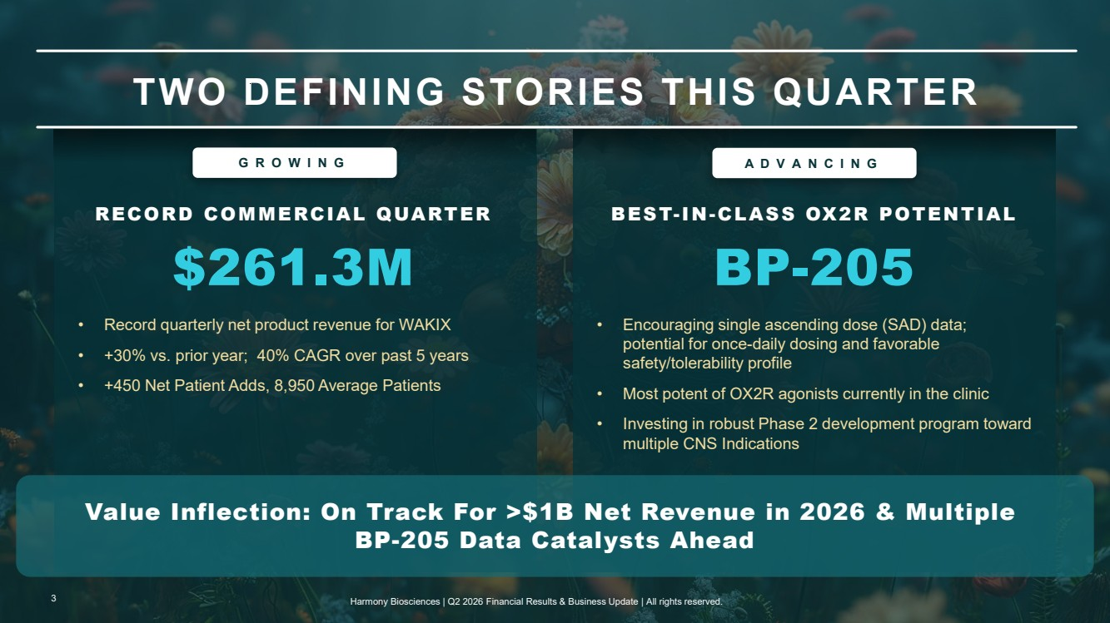 | TWO DEFINING STORIES THIS QUARTER RECORD COMMERCIAL QUARTER $261.3M • Record quarterly net product revenue for WAKIX • +30% vs. prior year; 40% CAGR over past 5 years • +450 Net Patient Adds, 8,950 Average Patients BEST-IN-CLASS OX2R POTENTIAL BP-205 • Encouraging single ascending dose (SAD) data; potential for once-daily dosing and favorable safety/tolerability profile • Most potent of OX2R agonists currently in the clinic • Investing in robust Phase 2 development program toward multiple CNS Indications Value Inflection: On Track For >$1B Net Revenue in 2026 & Multiple BP-205 Data Catalysts Ahead GROWING ADVANCING 3 Harmony Biosciences | Q2 2026 Financial Results & Business Update | All rights reserved.
 | 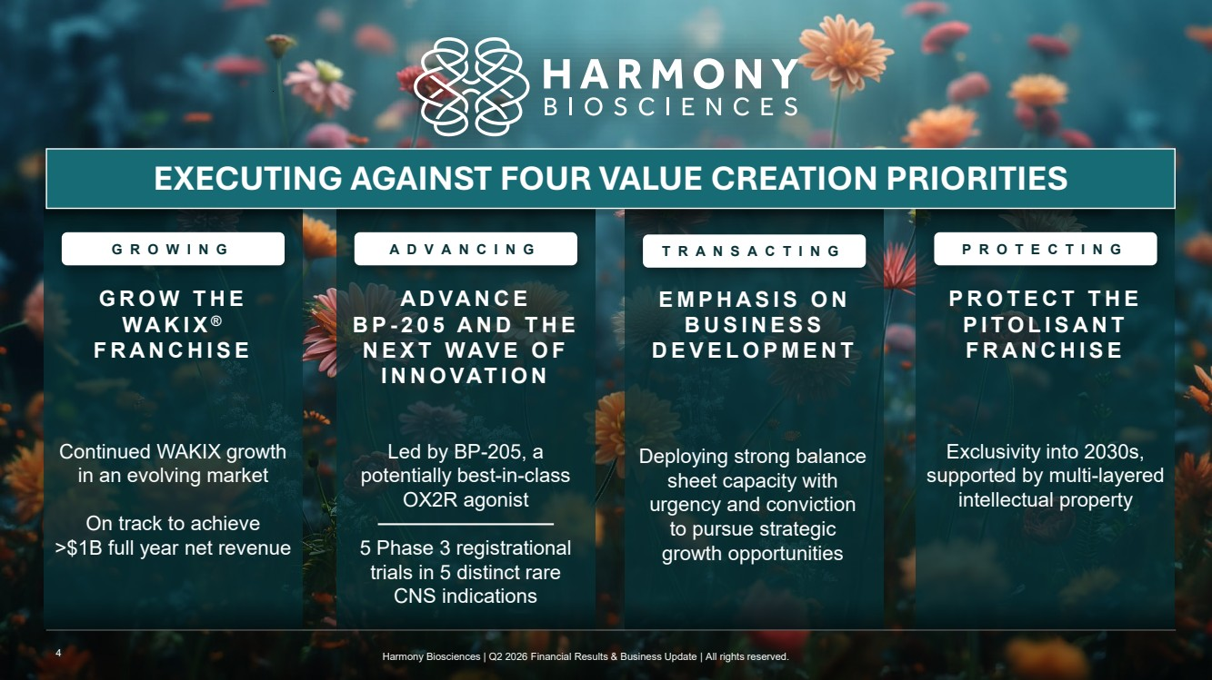 | Exclusivity into 2030s, supported by multi-layered intellectual property PROTECT THE PITOLISANT FRANCHISE Led by BP-205, a potentially best-in-class OX2R agonist 5 Phase 3 registrational trials in 5 distinct rare CNS indications ADVANCE B P - 205 AND THE NEXT WAVE OF INNOVATION Continued WAKIX growth in an evolving market On track to achieve >$1B full year net revenue GROW THE WAKIX ® FRANCHISE GROWING ADVANCING TRANSACTING PROTECTING Deploying strong balance sheet capacity with urgency and conviction to pursue strategic growth opportunities EXECUTING AGAINST FOUR VALUE CREATION PRIORITIES EMPHASIS ON BUSINESS DEVELOPMENT 4 Harmony Biosciences | Q2 2026 Financial Results & Business Update | All rights reserved.
 | 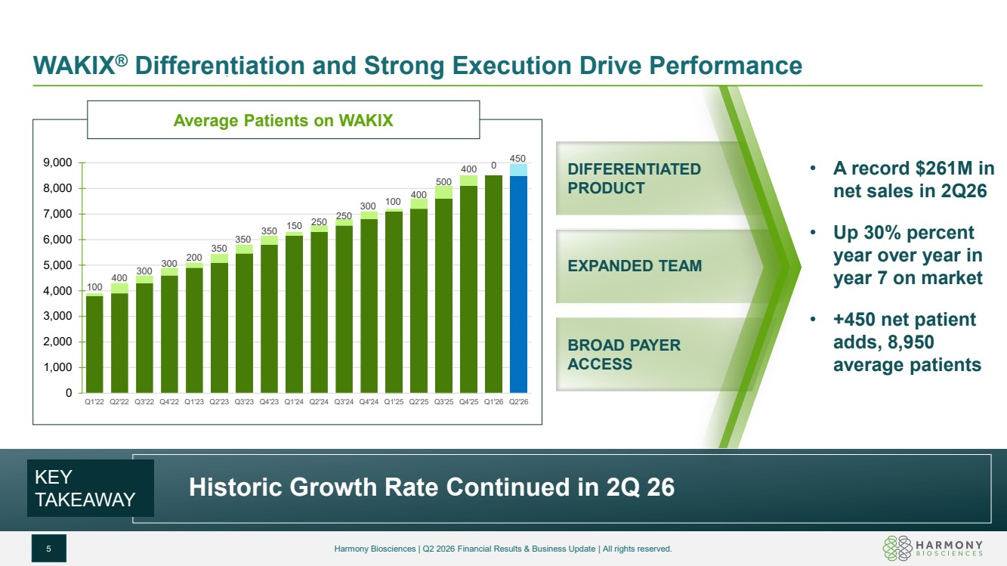 | WAKIX® Differentiation and Strong Execution Drive Performance 5 Harmony Biosciences | Q2 2026 Financial Results & Business Update | All rights reserved. KEY TAKEAWAY Average Patients on WAKIX 100 400 300 300 200 350 350 350 150 250 250 300 100 400 500 400 0 450 0 1,000 2,000 3,000 4,000 5,000 6,000 7,000 8,000 9,000 Q1'22 Q2'22 Q3'22 Q4'22 Q1'23 Q2'23 Q3'23 Q4'23 Q1'24 Q2'24 Q3'24 Q4'24 Q1'25 Q2'25 Q3'25 Q4'25 Q1'26 Q2'26 Historic Growth Rate Continued in 2Q 26 • A record $261M in net sales in 2Q26 • Up 30% percent year over year in year 7 on market • +450 net patient adds, 8,950 average patients BROAD PAYER ACCESS EXPANDED TEAM DIFFERENTIATED PRODUCT
 | 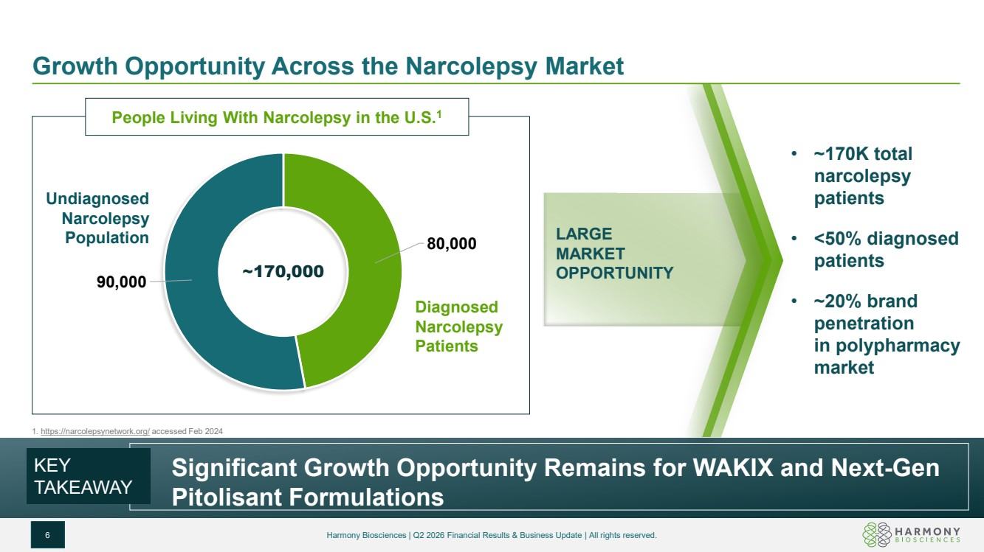 | Growth Opportunity Across the Narcolepsy Market • ~170K total narcolepsy patients • <50% diagnosed patients • ~20% brand penetration in polypharmacy market People Living With Narcolepsy in the U.S.1 80,000 90,000 ~170,000 Diagnosed Narcolepsy Patients Undiagnosed Narcolepsy Population KEY TAKEAWAY LARGE MARKET OPPORTUNITY 6 Harmony Biosciences | Q2 2026 Financial Results & Business Update | All rights reserved. Significant Growth Opportunity Remains for WAKIX and Next-Gen Pitolisant Formulations 1. https://narcolepsynetwork.org/ accessed Feb 2024
 | 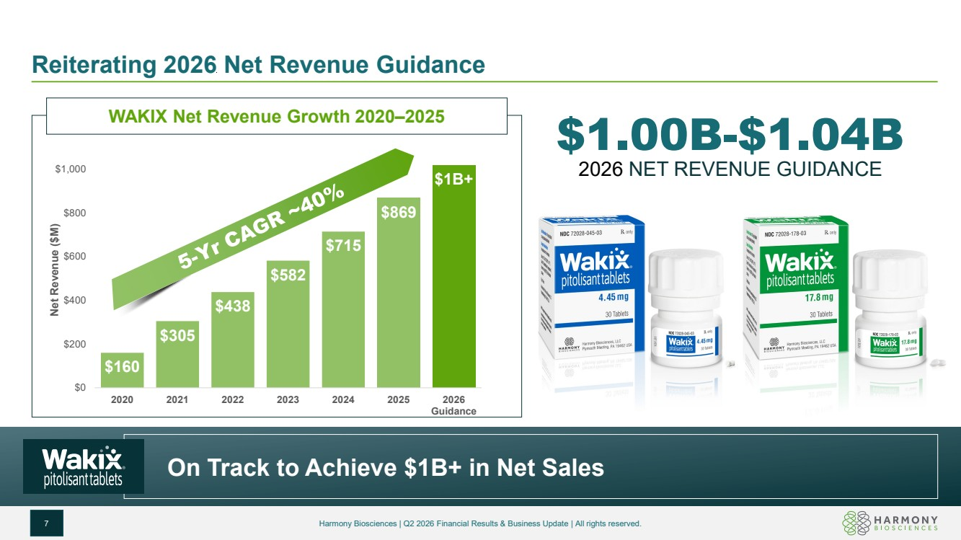 | Reiterating 2026 Net Revenue Guidance 7 Harmony Biosciences | Q2 2026 Financial Results & Business Update | All rights reserved. $1.00B-$1.04B 2026 NET REVENUE GUIDANCE WAKIX Net Revenue Growth 2020–2025 $160 $305 $438 $582 $715 $869 $1B+ $0 $200 $400 $600 $800 $1,000 2020 2021 2022 2023 2024 2025 2026 Guidance Net Revenue ($M) On Track to Achieve $1B+ in Net Sales
 | 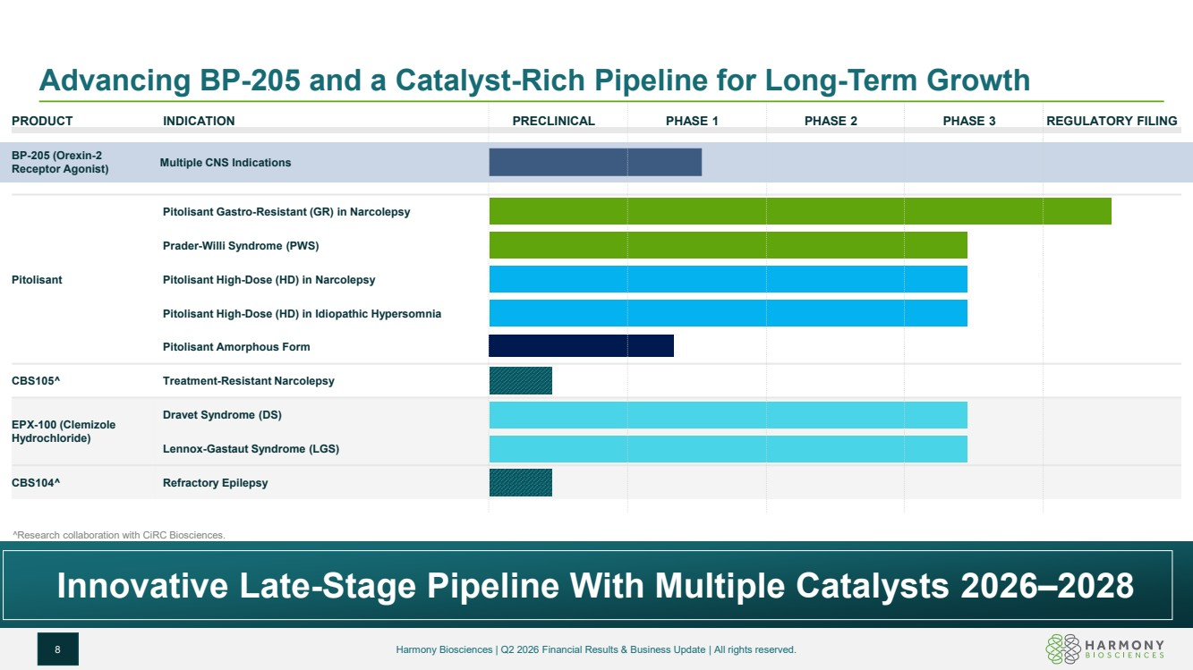 | Advancing BP-205 and a Catalyst-Rich Pipeline for Long-Term Growth 8 Harmony Biosciences | Q2 2026 Financial Results & Business Update | All rights reserved. PRODUCT INDICATION PRECLINICAL PHASE 1 PHASE 2 PHASE 3 REGULATORY FILING Research collaboration with CiRC Biosciences. Innovative Late-Stage Pipeline With Multiple Catalysts 2026–2028 BP-205 (Orexin-2 Receptor Agonist) Multiple CNS Indications Pitolisant Pitolisant Gastro-Resistant (GR) in Narcolepsy Prader-Willi Syndrome (PWS) Pitolisant High-Dose (HD) in Narcolepsy Pitolisant High-Dose (HD) in Idiopathic Hypersomnia Pitolisant Amorphous Form CBS105 Treatment-Resistant Narcolepsy EPX-100 (Clemizole Hydrochloride) Dravet Syndrome (DS) Lennox-Gastaut Syndrome (LGS) CBS104 Refractory Epilepsy
 | 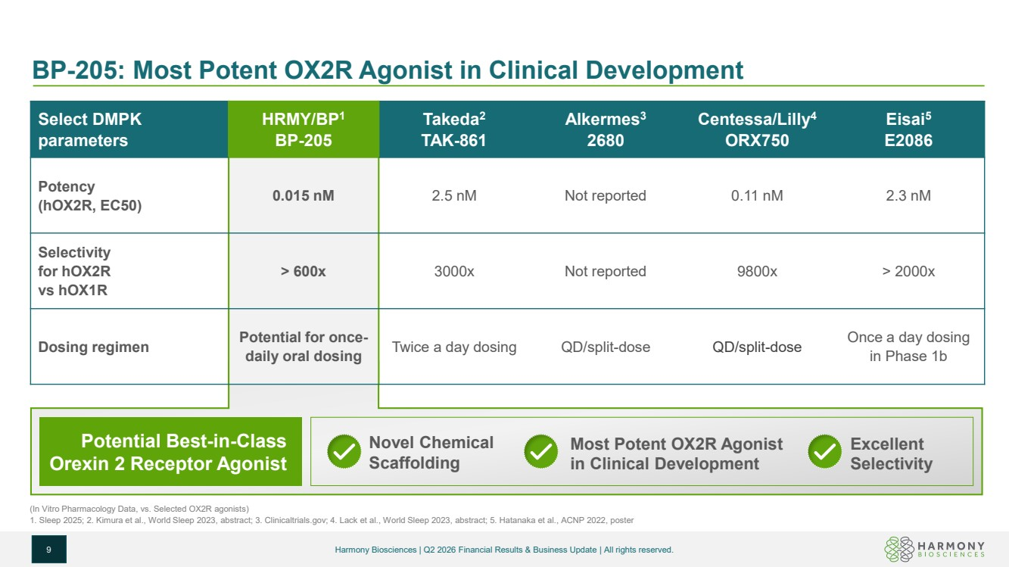 | Select DMPK parameters HRMY/BP1 BP-205 Takeda2 TAK-861 Alkermes3 2680 Centessa/Lilly4 ORX750 Eisai5 E2086 Potency (hOX2R, EC50) 0.015 nM 2.5 nM Not reported 0.11 nM 2.3 nM Selectivity for hOX2R vs hOX1R > 600x 3000x Not reported 9800x > 2000x Dosing regimen Potential for once-daily oral dosing Twice a day dosing QD/split-dose QD/split-dose Once a day dosing in Phase 1b BP-205: Most Potent OX2R Agonist in Clinical Development 9 (In Vitro Pharmacology Data, vs. Selected OX2R agonists) 1. Sleep 2025; 2. Kimura et al., World Sleep 2023, abstract; 3. Clinicaltrials.gov; 4. Lack et al., World Sleep 2023, abstract; 5. Hatanaka et al., ACNP 2022, poster Potential Best-in-Class Orexin 2 Receptor Agonist Novel Chemical Scaffolding Most Potent OX2R Agonist in Clinical Development Excellent Selectivity Harmony Biosciences | Q2 2026 Financial Results & Business Update | All rights reserved.
 | 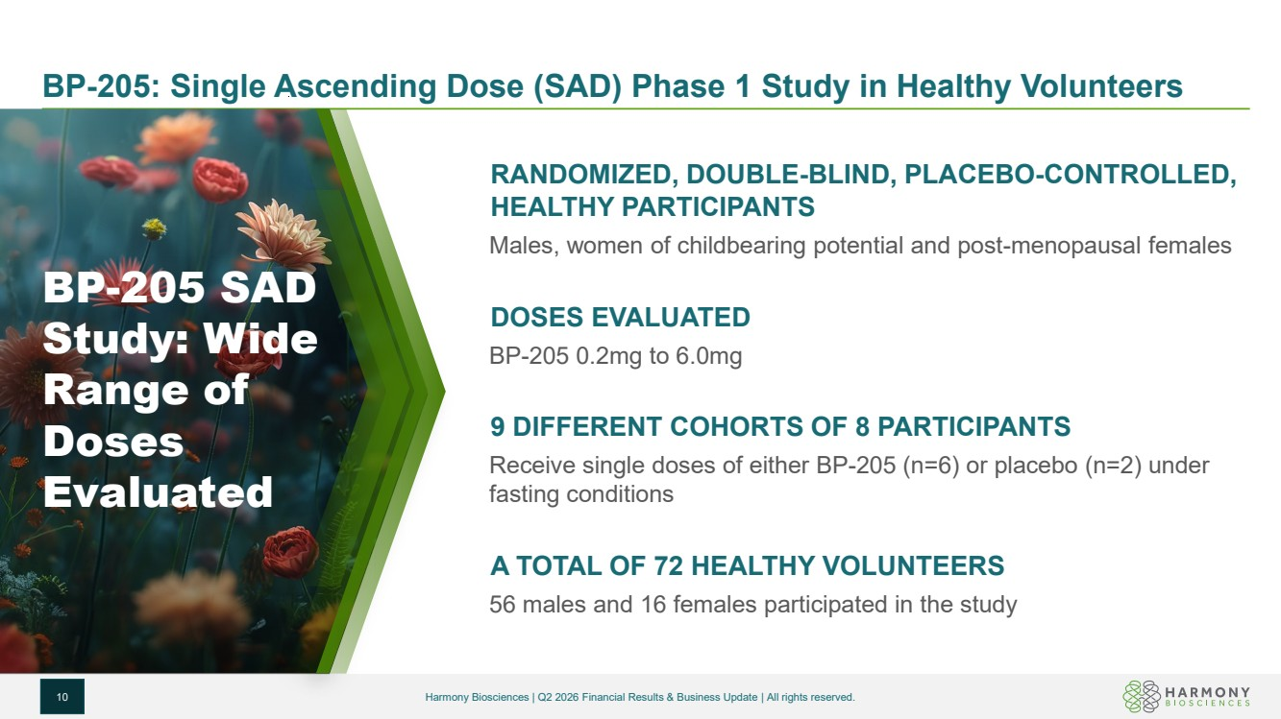 | BP-205: Single Ascending Dose (SAD) Phase 1 Study in Healthy Volunteers 10 Harmony Biosciences | Q2 2026 Financial Results & Business Update | All rights reserved. RANDOMIZED, DOUBLE-BLIND, PLACEBO-CONTROLLED, HEALTHY PARTICIPANTS Males, women of childbearing potential and post-menopausal females DOSES EVALUATED BP-205 0.2mg to 6.0mg 9 DIFFERENT COHORTS OF 8 PARTICIPANTS Receive single doses of either BP-205 (n=6) or placebo (n=2) under fasting conditions A TOTAL OF 72 HEALTHY VOLUNTEERS 56 males and 16 females participated in the study BP-205 SAD Study: Wide Range of Doses Evaluated
 | 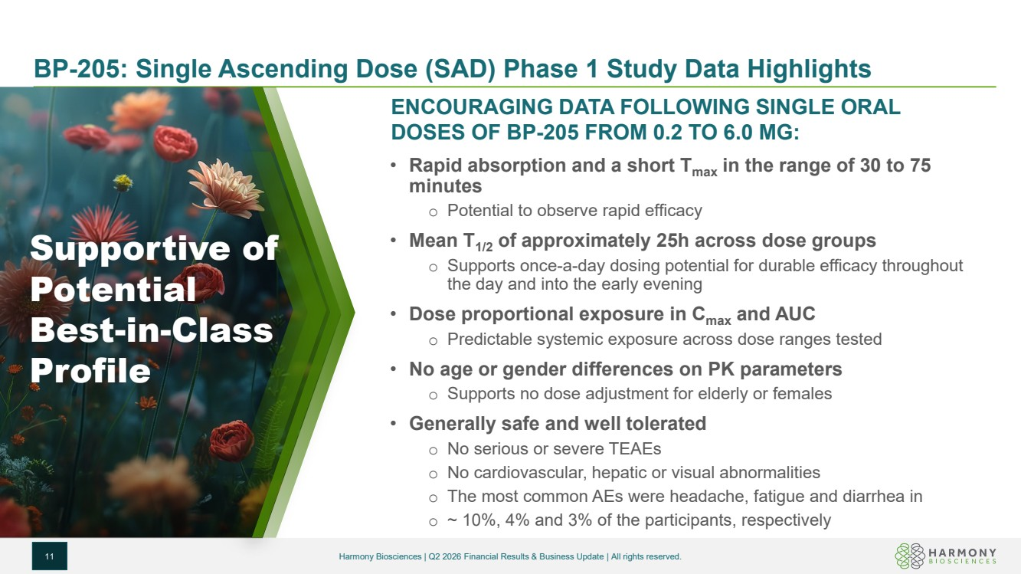 | BP-205: Single Ascending Dose (SAD) Phase 1 Study Data Highlights 11 Harmony Biosciences | Q2 2026 Financial Results & Business Update | All rights reserved. ENCOURAGING DATA FOLLOWING SINGLE ORAL DOSES OF BP-205 FROM 0.2 TO 6.0 MG: • Rapid absorption and a short Tmax in the range of 30 to 75 minutes o Potential to observe rapid efficacy • Mean T1/2 of approximately 25h across dose groups o Supports once-a-day dosing potential for durable efficacy throughout the day and into the early evening • Dose proportional exposure in Cmax and AUC o Predictable systemic exposure across dose ranges tested • No age or gender differences on PK parameters o Supports no dose adjustment for elderly or females • Generally safe and well tolerated o No serious or severe TEAEs o No cardiovascular, hepatic or visual abnormalities o The most common AEs were headache, fatigue and diarrhea in o ~ 10%, 4% and 3% of the participants, respectively Supportive of Potential Best-in-Class Profile
 | 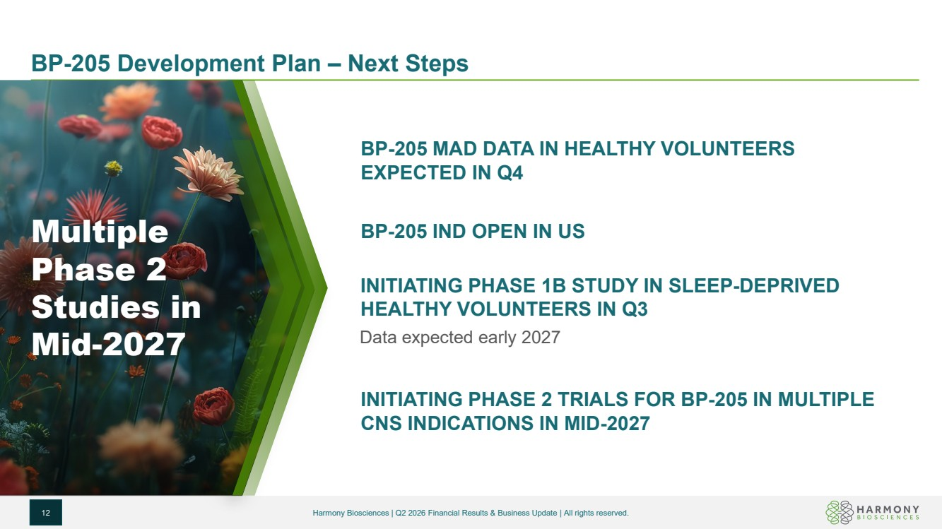 | BP-205 Development Plan – Next Steps 12 Harmony Biosciences | Q2 2026 Financial Results & Business Update | All rights reserved. BP-205 MAD DATA IN HEALTHY VOLUNTEERS EXPECTED IN Q4 BP-205 IND OPEN IN US INITIATING PHASE 1B STUDY IN SLEEP-DEPRIVED HEALTHY VOLUNTEERS IN Q3 Data expected early 2027 INITIATING PHASE 2 TRIALS FOR BP-205 IN MULTIPLE CNS INDICATIONS IN MID-2027 Multiple Phase 2 Studies in Mid-2027
 | 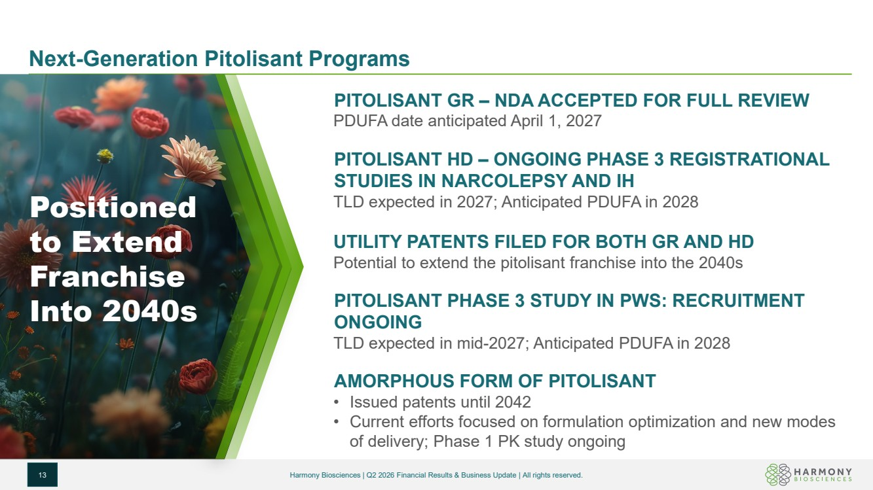 | Next-Generation Pitolisant Programs 13 Harmony Biosciences | Q2 2026 Financial Results & Business Update | All rights reserved. PITOLISANT GR – NDA ACCEPTED FOR FULL REVIEW PDUFA date anticipated April 1, 2027 PITOLISANT HD – ONGOING PHASE 3 REGISTRATIONAL STUDIES IN NARCOLEPSY AND IH TLD expected in 2027; Anticipated PDUFA in 2028 UTILITY PATENTS FILED FOR BOTH GR AND HD Potential to extend the pitolisant franchise into the 2040s PITOLISANT PHASE 3 STUDY IN PWS: RECRUITMENT ONGOING TLD expected in mid-2027; Anticipated PDUFA in 2028 AMORPHOUS FORM OF PITOLISANT • Issued patents until 2042 • Current efforts focused on formulation optimization and new modes of delivery; Phase 1 PK study ongoing Positioned to Extend Franchise Into 2040s
 | 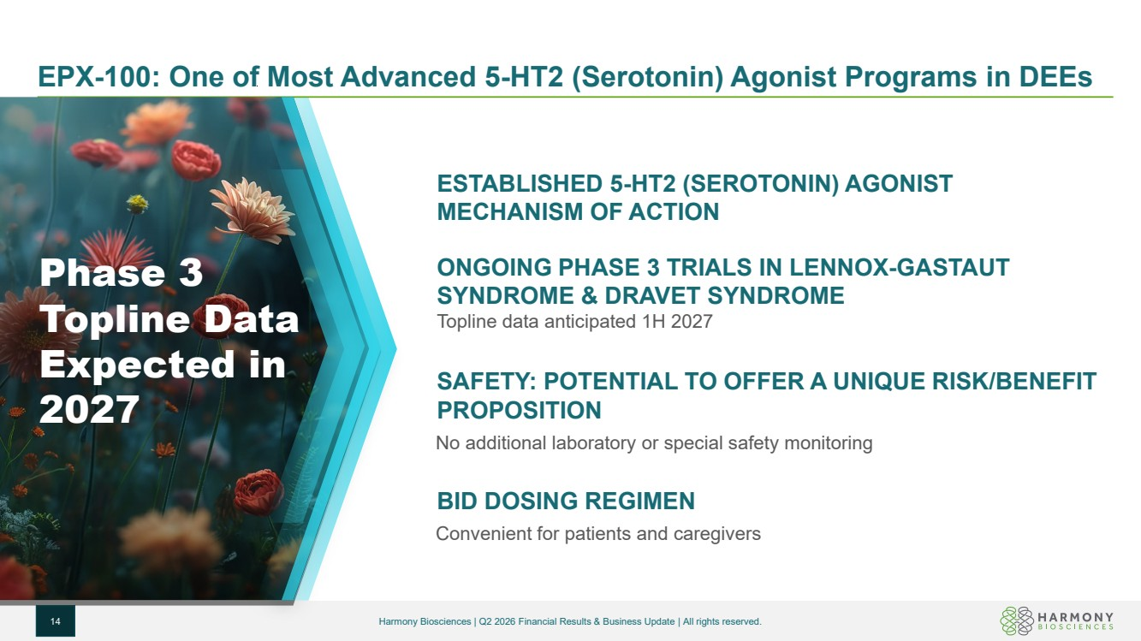 | EPX-100: One of Most Advanced 5-HT2 (Serotonin) Agonist Programs in DEEs 14 Harmony Biosciences | Q2 2026 Financial Results & Business Update | All rights reserved. ESTABLISHED 5-HT2 (SEROTONIN) AGONIST MECHANISM OF ACTION ONGOING PHASE 3 TRIALS IN LENNOX-GASTAUT SYNDROME & DRAVET SYNDROME Topline data anticipated 1H 2027 SAFETY: POTENTIAL TO OFFER A UNIQUE RISK/BENEFIT PROPOSITION No additional laboratory or special safety monitoring BID DOSING REGIMEN Convenient for patients and caregivers Phase 3 Topline Data Expected in 2027
 | 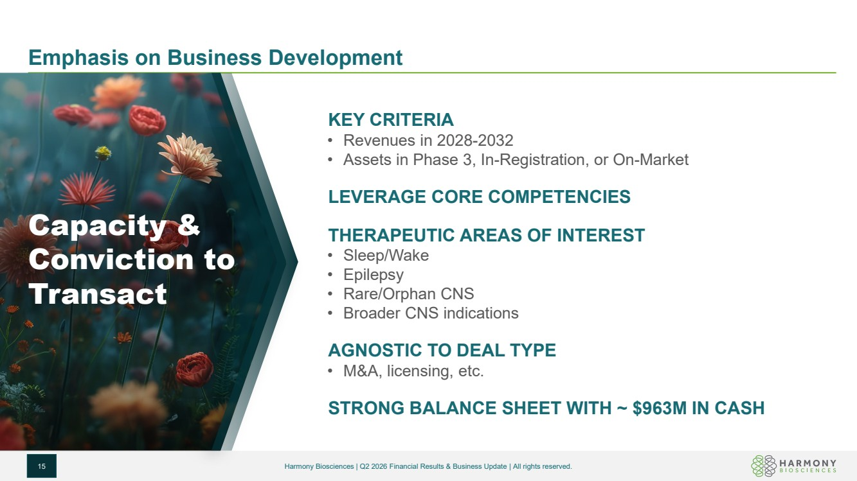 | Emphasis on Business Development 15 Harmony Biosciences | Q2 2026 Financial Results & Business Update | All rights reserved. KEY CRITERIA • Revenues in 2028-2032 • Assets in Phase 3, In-Registration, or On-Market LEVERAGE CORE COMPETENCIES THERAPEUTIC AREAS OF INTEREST • Sleep/Wake • Epilepsy • Rare/Orphan CNS • Broader CNS indications AGNOSTIC TO DEAL TYPE • M&A, licensing, etc. STRONG BALANCE SHEET WITH ~ $963M IN CASH Capacity & Conviction to Transact
 | 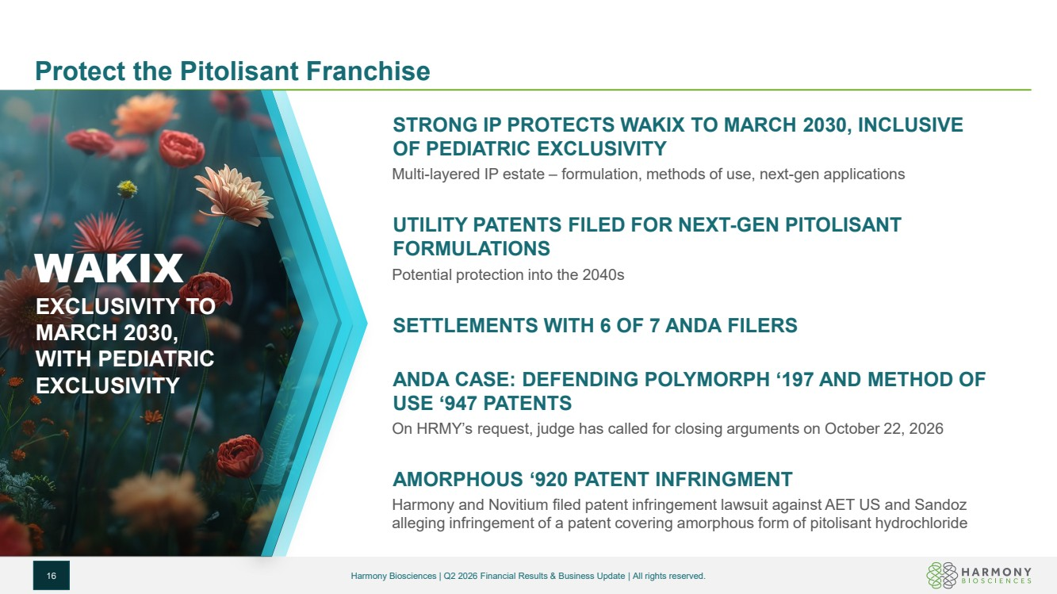 | Protect the Pitolisant Franchise 16 Harmony Biosciences | Q2 2026 Financial Results & Business Update | All rights reserved. WAKIX EXCLUSIVITY TO MARCH 2030, WITH PEDIATRIC EXCLUSIVITY STRONG IP PROTECTS WAKIX TO MARCH 2030, INCLUSIVE OF PEDIATRIC EXCLUSIVITY Multi-layered IP estate – formulation, methods of use, next-gen applications UTILITY PATENTS FILED FOR NEXT-GEN PITOLISANT FORMULATIONS Potential protection into the 2040s SETTLEMENTS WITH 6 OF 7 ANDA FILERS ANDA CASE: DEFENDING POLYMORPH ‘197 AND METHOD OF USE ‘947 PATENTS On HRMY’s request, judge has called for closing arguments on October 22, 2026 AMORPHOUS ‘920 PATENT INFRINGMENT Harmony and Novitium filed patent infringement lawsuit against AET US and Sandoz alleging infringement of a patent covering amorphous form of pitolisant hydrochloride
 | 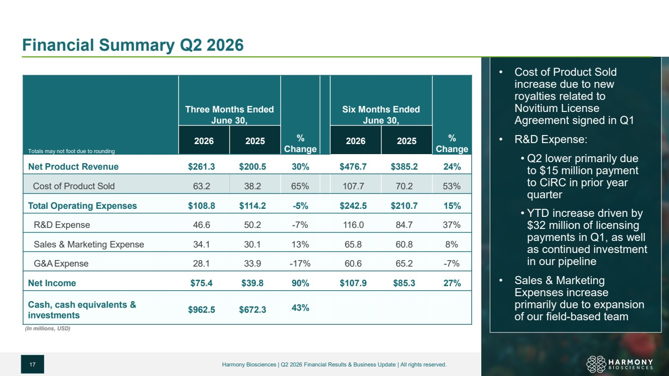 | Financial Summary Q2 2026 17 • Cost of Product Sold increase due to new royalties related to Novitium License Agreement signed in Q1 • R&D Expense: • Q2 lower primarily due to $15 million payment to CiRC in prior year quarter • YTD increase driven by $32 million of licensing payments in Q1, as well as continued investment in our pipeline • Sales & Marketing Expenses increase primarily due to expansion of our field-based team Totals may not foot due to rounding Three Months Ended June 30, % Change Six Months Ended June 30, % Change 2026 2025 2026 2025 Net Product Revenue $261.3 $200.5 30% $476.7 $385.2 24% Cost of Product Sold 63.2 38.2 65% 107.7 70.2 53% Total Operating Expenses $108.8 $114.2 -5% $242.5 $210.7 15% R&D Expense 46.6 50.2 -7% 116.0 84.7 37% Sales & Marketing Expense 34.1 30.1 13% 65.8 60.8 8% G&AExpense 28.1 33.9 -17% 60.6 65.2 -7% Net Income $75.4 $39.8 90% $107.9 $85.3 27% Cash, cash equivalents & investments $962.5 $672.3 43% (In millions, USD) Harmony Biosciences | Q2 2026 Financial Results & Business Update | All rights reserved.
 | 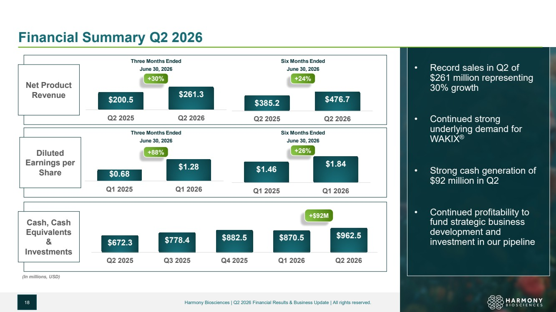 | Financial Summary Q2 2026 18 • Record sales in Q2 of $261 million representing 30% growth • Continued strong underlying demand for WAKIX® • Strong cash generation of $92 million in Q2 • Continued profitability to fund strategic business development and investment in our pipeline $200.5 $261.3 Q2 2025 Q2 2026 $672.3 $778.4 $882.5 $870.5 $962.5 Q2 2025 Q3 2025 Q4 2025 Q1 2026 Q2 2026 Three Months Ended June 30, 2026 (In millions, USD) Net Product Revenue Diluted Earnings per Share Cash, Cash Equivalents & Investments +30% +$92M Three Months Ended June 30, 2026 $0.68 $1.28 Q1 2025 Q1 2026 $385.2 $476.7 Q2 2025 Q2 2026 Six Months Ended June 30, 2026 $1.46 $1.84 Q1 2025 Q1 2026 Six Months Ended June 30, 2026 +24% +88% +26% Harmony Biosciences | Q2 2026 Financial Results & Business Update | All rights reserved.
 | 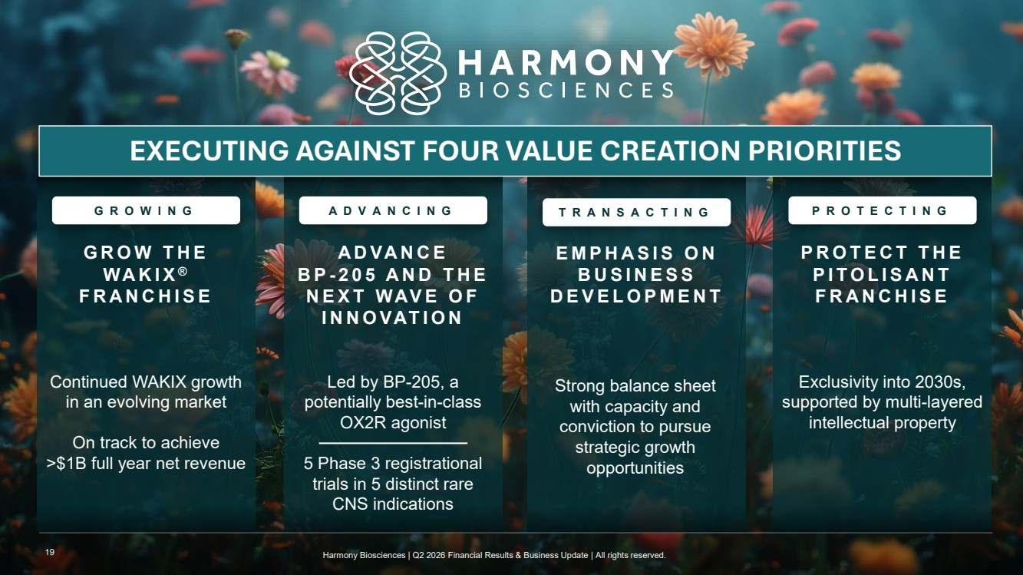 | Exclusivity into 2030s, supported by multi-layered intellectual property PROTECT THE PITOLISANT FRANCHISE Led by BP-205, a potentially best-in-class OX2R agonist 5 Phase 3 registrational trials in 5 distinct rare CNS indications ADVANCE B P - 205 AND THE NEXT WAVE OF INNOVATION Continued WAKIX growth in an evolving market On track to achieve >$1B full year net revenue GROW THE WAKIX ® FRANCHISE GROWING ADVANCING TRANSACTING PROTECTING Strong balance sheet with capacity and conviction to pursue strategic growth opportunities EXECUTING AGAINST FOUR VALUE CREATION PRIORITIES EMPHASIS ON BUSINESS DEVELOPMENT 19 Harmony Biosciences | Q2 2026 Financial Results & Business Update | All rights reserved.
 |  | company/harmonybiosciences/ @harmonybio harmony_biosciences www.harmonybiosciences.com

